
Story

Date | 1 November 2026
Team ID
Project Name | Electric Vehicle Market Performance & insights
Maximum Marks | 5 Marks

Tableau Story is a feature that allows users to present data insights through a sequence of dashboards and visualizations. It helps communicate complex EV market information in a clear and interactive manner.

In this project, the Tableau Story EV_Market_story presents global EV manufacturing, manufacturing density, market breakdown, leading manufacturers, and price-versus-range analysis.

Story Overview

The story consists of the following sections:

1. Global EV Manufacturing: Displays the geographical distribution of EV manufacturing and annual sales across different countries.
2. Manufacturing Density: Highlights the concentration of EV manufacturing across regions.
3. Market Breakdown: Explains the distribution of EV sales across different market segments.
4. Manufacturing Leaders: Compares leading EV manufacturers based on their performance.
5. Price vs. Range Dynamics: Examines the relationship between vehicle prices and driving range.

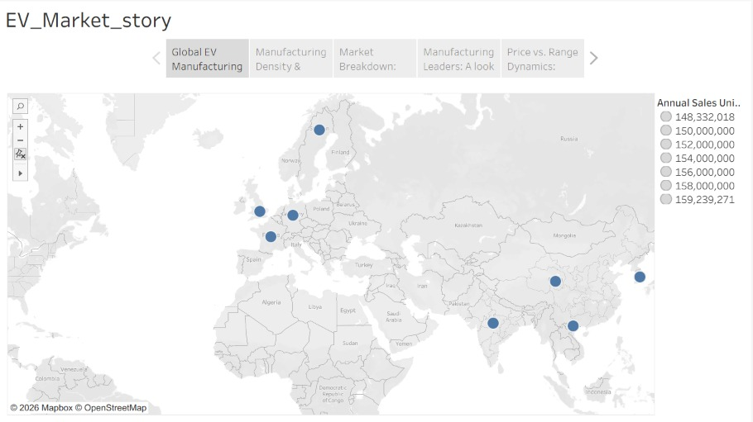

Observations:
Global Distribution: The map highlights EV manufacturing activity across different countries worldwide.
Regional Performance: Manufacturing activity is spread across Europe and Asia, showing their importance in the EV market.
Annual Sales: The map displays annual sales values ranging approximately from 148.33 million to 159.24 million units.
Manufacturer Comparison: The story provides a comparison of leading manufacturers and their market performance.
Pricing Insights: Price-versus-range analysis helps understand differences in vehicle pricing and driving capabilities.
Business Insights: The story helps identify global market patterns and supports better EV industry decisions.

Activity 2:
Publish Story on Tableau Public and Paste Public link below
https://public.tableau.com/app/profile/soumil.jaiswal/viz/Ev_Market_Performance/EV_Market_story?publish=yes

